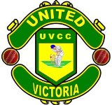United Victoria Cricket Club

Victoria District and Cricket Association

Victoria, British Columbia

Sponsorship Proposal for
2012-2014 Cricket Seasons

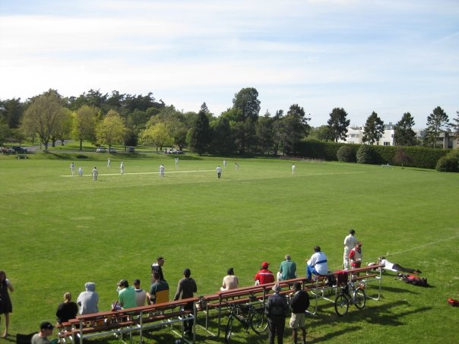

Cricket in Canada and Victoria
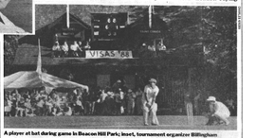
Cricket has a rich heritage in Canada. It has been played in Canada since 1745. The world’s first international sporting fixture – a cricket match between Canada and the United States – took place in Montreal in 1844. Cricket was so popular in the newly formed nation of Canada that in 1867 the game was declared the National Sport by the first Prime Minister, Sir John A. MacDonald and his Cabinet. In 1886 the West Indies cricket team made its first overseas tour to Canada, playing in four cities – Montreal, Ottawa, Toronto, and Hamilton. Today, Cricket is the most watched and second most played game in the world.

Victoria has a long and rich Cricket history and has been a favoured destination for many touring sides with teams from all over the world visiting to participate in a game of Cricket. Cricket has been played in Victoria since 1863 with teams from Cowichan, Metchosin, OakBay, and Victoria have competed for the championship title to represent Victoria in the BC championship game. Cricket is also played at the school level especially at St. Michaels University School (SMU) and the University of Victoria (UVIC) and is continuously attracting young players.
Currently, more than 500 adults participate during the regular season which runs from April to September. These games can attract 100 – 500 spectators. During the season other competitions are held, in particular the Victoria International Six‑a‑Side (VISAS) Cricket Festival which has been held every second year since 1986. VISAS includes teams from all over the world and draws 200 – 300 spectators every day at the Beacon Hill Park ground.

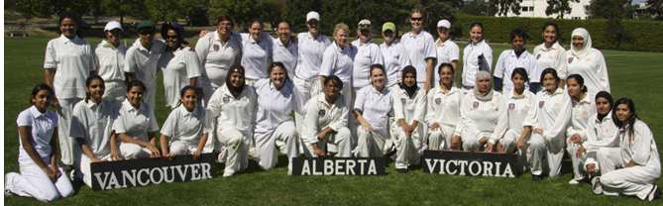
About United Victoria Cricket Club

The United Victoria Cricket Club (UVCC) was formed in 2009 with a mission to field a team combining the experience of senior players and the talent of young players to become the leading Victorian Cricket Club, to develop and promote opportunities for the community to participate in sport, physical activity and recreation, and to hold periodic coaching clinics for youngsters under the watchful eye of certified coaches.
United Victoria Cricket Club is located at Beacon Hill Park Cricket Pavilion.

Club Achievements:
UVCC has won the Payne Cup (Round Robin competition), the Times Colonist Cup (Play-off champion) four years in a row (2009, 2010, 2011, 2012), and the VDCA T20 cup in 2010, 2011and 2012.
Being the champions of the Victoria and District Cricket Association (VDCA), UVCC has represented Victoria in the BC Championship Games in 2009, 2010, 2011 and 2012 its team members have represented the BC team in the Canadian National Championship games in Toronto.
UVCC's efforts for the improvement of cricket in Victoria, on and off the field, are greatly appreciated by VDCA. In recognition of these efforts UVCC players have won the Volunteer of the Year and Sportsman of the Year trophies.
UVCC after winning the 2009 Championship title
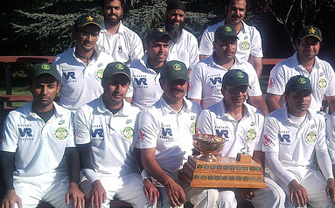

UVCC at VDCA annual award dinner ceremony 2010
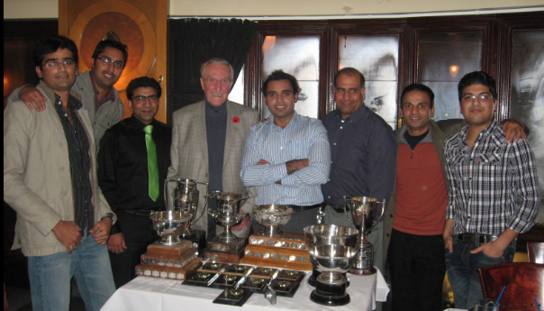

UVCC after winning the 2011 Championship title
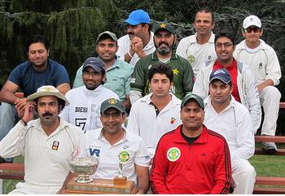
Sponsorship of UVCC

Sponsorship of UVCC has the following advantages:

- Involvement in our local community, help local community youth to become involved in a sport related activity as part of funds will be used to involve and train youth in coaching clinics and to purchase coaching materials
- Assistance and contribution of funds to the UVIC cricket team
- Exposure of your company’s products and services to the community
- Promotion on both the UVCC and VDCA websites which have over 1,000 visitors per week
- Listing your business in the annual VDVCA hand book which is distributed free of charge to the cricketing community; in 2010 over 800 hand books distributed and this number increases year over year
- Coverage in the local media and in local newspaper as a team sponsor
- Promotional products, handouts, and leaflets
- Ability to attend our annual AGM as a VIP guest
- Your company logo on the UVCC uniform, cap, bats, gear bags, and training uniform

Following are the sponsorship packages with package details to choose and help promote sports activity in Victoria, BC.

*** There will only be one Platinum package sponsor and will be known as official sponsor of UVCC and will be given a prominent area to display logo on uniform and other equipment.

Package Includes | Platinum | Gold | Silver
Company’s Logo on Club Uniform
Company’s Logo on Training Uniform

Company’s Logo on Equipment
Distribution of Company’s catalogues and flyers
Distribution of Company’s catalogues and flyers
Website recognition
Color advertisement in VDCA handbook
B&W advertisement in VDCA handbook
Volunteer players’ participation in company’s community events
Promote company in coaching clinics
Special VIP invitation to Presentation night
Cost | $5,000 per year | $2,500 per year | $1,500 per year

United Victoria Cricket Club SPONSOR AGREEMENT

Name:
First: __________________ Last: ______________________

Title: __________________

Company: ______________________________________________

Address: _______________________________________________

_______________________________________________________

Phone: ( ) _____ - _________

Email: ___________________________________

This agreement becomes a binding document upon payment in full and signature of both sponsor and the UCVV representative. This agreement guarantees fulfillment of the items listed on the sponsor program benefits (Sponsor Package) and cost sheet. The sponsor will provide items such as: Website link information, company banner, brochures, contact information, etc to optimise exposure benefits and to fulfill the UVCC obligations of the package chosen.

SPONSORSHIP PACKAGE CHOSEN:

Platinum | ------- |  |  | Gold | -------
Silver | -------

____________________ ___________________
Signature of Sponsor Date

________________________________________________ ___________________
Signature of UVCC Date
Representative

