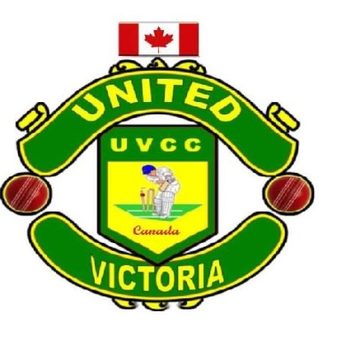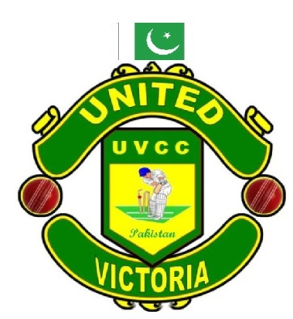

Board of Directors

United Victoria Cricket Club and United Victoria Cricket Academy.

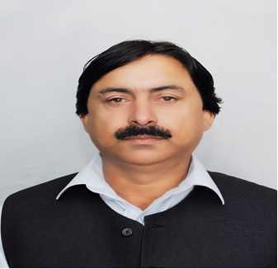 | 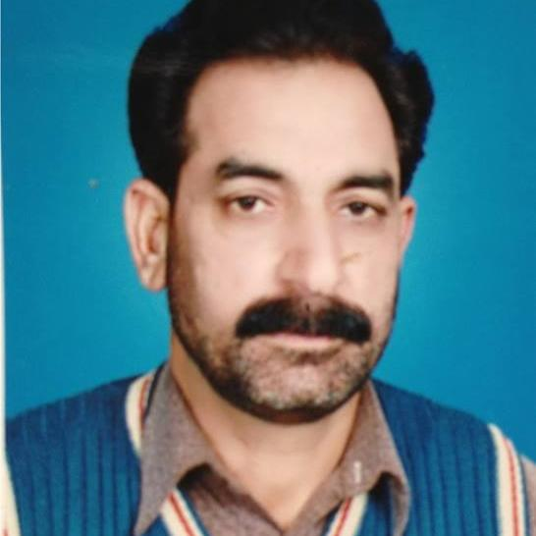 | 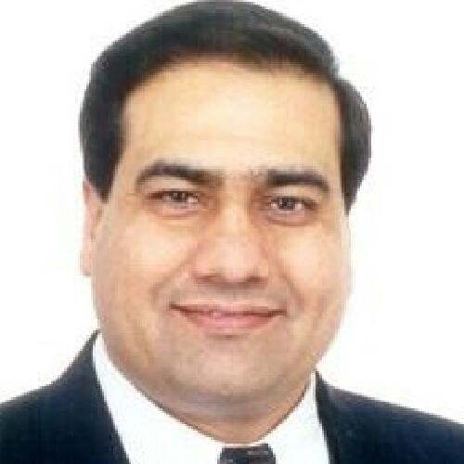
Mr. Aamir Nawab  Designation: PATRON  Advisor to Chairman PCB  Ex-Member Governing Body PCB  Ex-President ARCA. | Name: Mr. Zahid Saeed  Designation: President ARCA.  Pakistan | Name: Mr. Javed Khan  Designation:CEO / DIRECTOR  President United Victoria Cricket Club/Academy  Qualified Level 1st Coach and Umpire  Ex-President Victoria Cricket Association.  javedatunitedvictoria@gmail.com
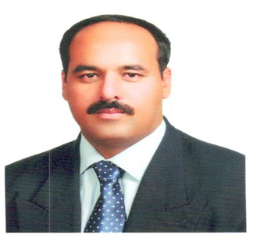 | 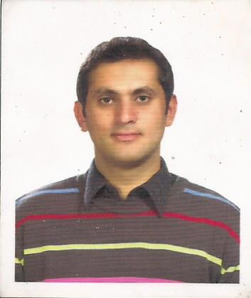 | 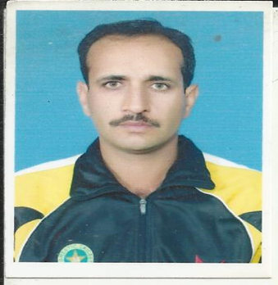
Name: Mr. Shaukat Gul Jadoon  Designation:  HEAD COACH  PCL Qualified Level 1st& Level 2nd  ICC Award for Development Cricket. | Name: Mr. Waqar Orakzai  Designation: MANAGER  First Class Cricketer PCB Qualified Level 1st Coach. | Name: Mr. Saqib Faqeer  Designation: COACHING STAFF  Qualified PCB Level 3rd Coach.  Fielding Coach Afghanistan Cricket Team.  Specialized in Batting & Fielding.
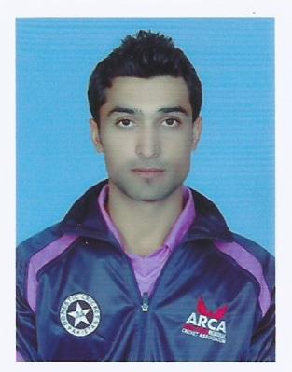 | 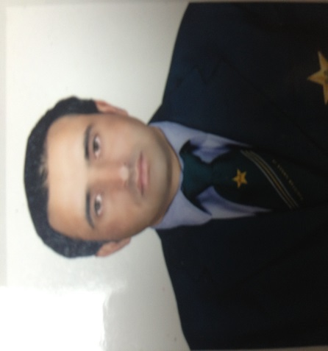 | 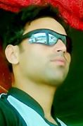
Name: Mr. Ramiz Ahmed  Designation: FIELDING COACH  First Class Cricketer PCB Level Coach. | Name: Mr. Riaz Khail  Designation: BATTING COACH  Qualified ECB Level 2nd Coach  First Class Cricketer. | Name : Mr. Ikram Ullah  Designation: BOWLING COACH  First Class Cricketer  PCB Level 1st Coach.

NO Photo | 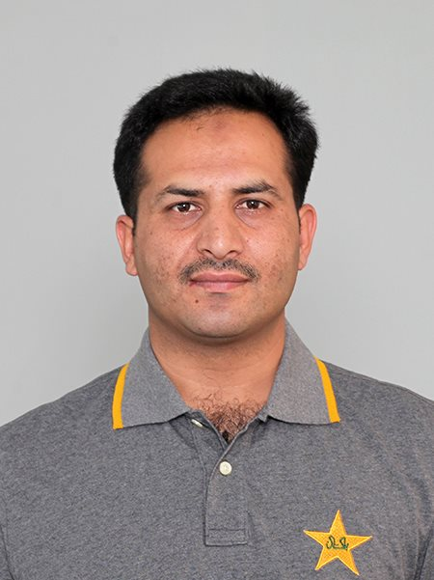 | NO Photo
Mr. Abid Zaman Khan  Designation: ASSASTANT COACH  PCB Qualified Level 1st Coach.  HEAD COACH  S G Jadoon Academy. | Name: Mr. Liaqat Ali  Designation: PHYSIO  Physio Therapist PCB Since 2007.  QUALIFICATION BPST  MS. Sports Science  MPH Thesis. | Name: Mr. Aamir Sharif  Designation: TRAINER  Qualified PCB Trainer
 | 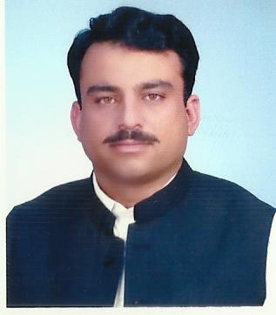
 | Name: Mr. Ikhlaq Ahmed Khan,  Advocate  Designation: President Abbottabad  DCA | Name: Mr. Amjad Khan Jadoon  Designation: Secretary Abbottabad DCA

