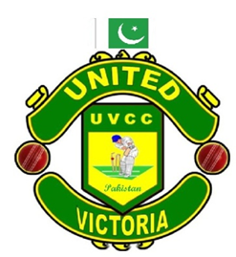
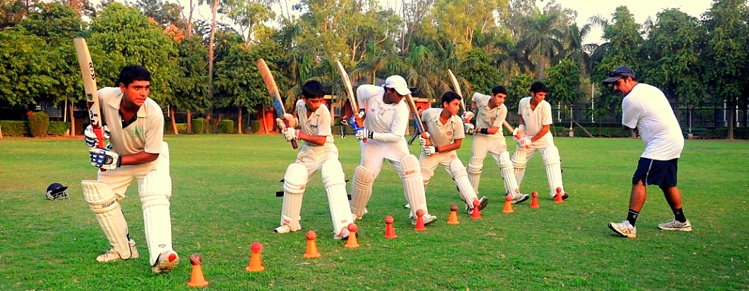
School Based Cricket Academy
- Cricket Academy. School

Objective:
We use the LATEST equipment and technology as well as coaching techniques to help children IMPROVE their Cricket skills.
There is no denying that Cricket is perhaps the most loved game in Pakistan, and over the years with the accomplishments of the National Team along with the fame and glamour associated with the game the younger generation dream of being international cricketers. Why not help them achieve this dream?
To do so, we need to spot and nurture talent at the grass root level, i.e. at the basic school level. We feel that a school of your repute should take a lead in this and create the wherewithal to coach talented young schoolboys competently professionally and sincerely.
We are fortunate to have with us highly respected and brilliant coach in the form of Mr. Younus Khan Pakistani Cricketer. We plan to use his acumen and expertise to provide specialized and expert coaching in cricket to hone the skills of selected school boys and young talented players.
The ultimate aim is to bring your School on the cricket map of Pakistan in the near term and national level in the long run. We intend picking up few of the boys from schools and hopefully the ‘best’ and ‘most talented’ can possibly represent the country in the under 19 category, thereafter sky is the limit. We are sanguine that together we can realize the dreams of your school children. With the support and involvement of Mr. Saqib Faqeer Fielding Coach Afghanistan Cricket Team. Specialized in Batting & Fielding. And his support staff we would be able to give expertise coaching to the young kids.
Specialized Coaching Set Up:
- Specialized Coaching means ‘Quality’ and not ‘Quantity’.
- Students to be divided in 3 age groups :
- 9 to 12 years 13 to 15 years and 15 years and above.
- 8 hours (4 sessions of coaching during a week).
- Maximum strength of each group shall be 20 players.
- Total number of players inclusive of all three age groups will be 60.
- Sub Coaches will work under guidance of Head Coach
- All the students will be provided with a Picture ID
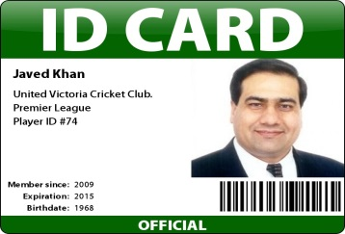

Cricketing Exposure:
- Video Analysis of players on regular basis.
- Bowling Machine to coach players.
- A number of cricket matches to be conducted during holidays when the school is closed.
- Exposure to talented players of the school by way on inter-school cricket competitions and touring different countries is the summer vacation.
- Opportunity for selection trials at state level.
- Cricket equipment ‘free of cost’ to the ‘outstanding cricketer’ in the school.
- Physical trainer to be assigned for fitness of players.
- Prominent international players to share tips with youngsters on occasionally.
- Progress reports of players to be published online weekly at www.unitedvictoria.com
- Updates on our Facebook page
- Balls for the academy and ground staff will be looked after by Mr. Waqar Orakzai.

Infrastructure Requirements:
We can do a free of cost appraisal of your schools current sports field setup and suggest cost effective ways to upgraded it accommodate the required cricket academy. Though it would be ideal to have an independent ground for the cricket academy facilities, we will start with your existing ground itself.
This upgrade usually consists of upgrading your existing ground cricket pitch and bring up to actual match playing condition. Also provide for practice pitch, nets areas & coaching facilities.
Our company provide professional services to supervise and install all the facilities on your ground on a turnkey bases, under expert guidance of our esteemed coach Mr. Waqar Orakzai.
We promise to bring up these facilities up to international standards worthy of your schools high reputation.

Commercials & Revenue Sharing

This aspect of the proposed project would be discussed further after our initial meeting. However it would be prudent to mention that it certainly will be a mutually beneficial proposition for both our establishments.

For any further information please Contact us
Individual Coaching:
Individual coaching sessions can be arranged with Mr. Waqar Orakzai One to one coaching specifically for the individual, our packages for individual coaching are with and without accommodation and the duration of stay of the individual. The accommodation is guest house type and is in the heart of Abbottabad colony just a 10 min drive to the cricket academy.
On special request and for outstation & international trainees the academy can arrange for Mr. Saqib Faqeer to be available for personal one to one training sessions. These individual training sessions will be separate from our academy’s curriculum over & above the regular academy days.
These sessions have to be pre booked. The academy can provide, at extra charges, boarding and lodging facilities at our guest house in Pakistan at Abbottabad With is conveniently situated at a 10 min driving distance from the academy grounds. Please contact us by filling up the form here and we will revert back to you promptly.
Professional Equipment
Our Academy in collaboration with has a special arrangement with.

Coaches
Mr. Saqib Faqeer Member of the golden era which changed the face of Pakistan Cricket in the 19’s,
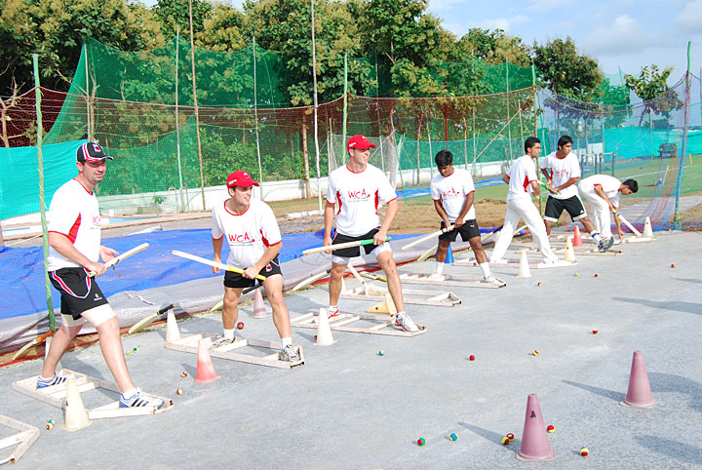
Company Overview
Creating Cricket Stars of Tomorrow! Cricket
Description
Mission:
To provide the highest standard of coaching and programs for all ages
To provide a safe and healthy environment, conducive to development
To provide the best playing opportunities for our players
To provide assistance and guidance for players to help them achieve their goals
Creating Cricket Stars of Tomorrow! Cricket.
General Information
If you wish to successfully coach or play the game of cricket you must have an intimate knowledge of the fundamental techniques of each element of the game.

Our Facilities

United Victoria Cricket Club/Academy (Pakistan)
Abbottabad Cricket Stadium
Murree Road Nawanshehr, Abbottabad
Abbottabad, 22010

Pakistan

The United Cricket Academy is situated in the Abbottabad Facilities include:
• A grass wicket training facility
• A fully three lane wet weather training facility
• Bola Merlyn Spin Bowling Machine (only one in Pakistan!)
• Bola Pace/Swing Bowling Machine
• Bola Fielding Rig
• Bola Youth Throw down Machine
• All Modern Coaching Aids and Equipment
• Full Run up's for Bowlers
• Sliding Dividing nets and Sightscreens
• Video Analysis unit and Classroom
• Gym
• Extra Batting/Fielding Skill Development Area
•
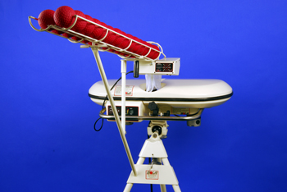
Cricket Training Equipment
Our Academy will provide state-of-the-art equipment’s.
Cricket Training Equipment - We can provide you with all the Cricket Training Equipment you will need to get you or your team to the level you want to be
Our Cricket Coaching Equipment and Cricket Training Aids are split into four categories; we offer specific products for improving your batting, bowling, catching, and fielding.
We also provide additional Cricket Training Equipment to specifically improve fitness, as well as ice baths for quick recovery.
Pitch Vision for Coaches
Pitch Vision is a revolutionary cricket coaching system that will allow batting, bowling and fielding performance to be automatically measured, compared and improved. Line and Length, Ball Speed, shot selection, scoring against simulated teams, batsman’s foot work, scoring against simulated field settings, records of wicket balls, accuracy, and automatic player ID are just some of the features available to each player. All of this without the use of cameras, or any other impractical equipment – and for about the price of a bowling machine. It’s a piece of kit that can be used by an individual, or the entire class, squad, team simultaneously. You don’t have to give up an entire net for 1 player, or invest in something that can only be used by one person at a time.
JUGS Cricket Machines
The JUGS Cricket machine is the most widely used bowling machine in the world. Its patented “gooseneck” design provides a full range of movement to adjust for all types of deliveries including fast risers, in–swing, out-swing, and slow-spins.
It simulates both left and right-handed bowlers and its swivel-design base casting provides 360 movements for a variety of fielding drills.
Fitness Training
Physical fitness is crucial and improves every facet of the cricketer's game.
Each cricketer will have his own fitness training program which reflects his specific needs. The majority of the time we will bring the cricketer out of the gym – will be using playground for these fitness sessions.
Besides improving overall levels of fitness, the program will focus on those areas specific to the needs of the game of cricket e.g. the fitness needs of an opening batsman are quite different to those of an opening bowler.
A fitness test is carried out in January and March. All tests are performed in accordance with Cricket Australia’s standardized fitness test protocols (including 20 m sprint times, jump heights, turn times). In addition, skinfolds are taken by an accredited tester (ISAK level 1) to assess body composition. Individual fitness reports are provided to each player. These reports can be sent to your coach at home.
Cricket and training gear
Academy cricketers are provided with a training vest, t-shirts and shorts which must be worn during fitness training sessions and cricket nets. Cricketers do have to bring with them their own ‘whites’ for match play and their own recreational clothing.

