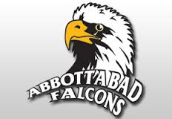
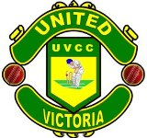

Victoria District and Cricket Association

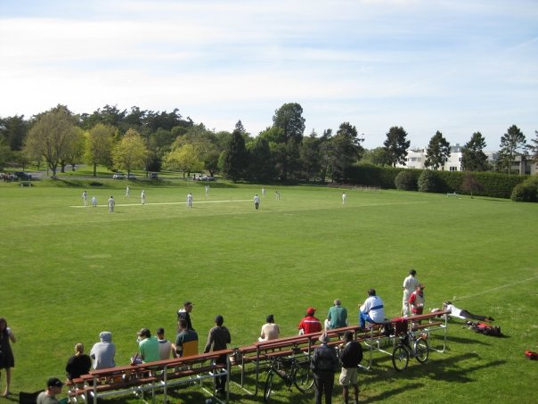

United Victoria Cricket Academy
Abbottabad Cricket Stadium
Abbottabad ,Pakistan
Sponsorship Proposal For United Victoria Cricket Academy

Cricket in Canada and Victoria
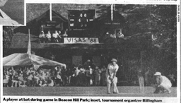
Cricket has a rich heritage in Canada. It has been played in Canada since 1745. The world’s first international sporting fixture – a cricket match between Canada and the United States – took place in Montreal in 1844. Cricket was so popular in the newly formed nation of Canada that in 1867 the game was declared the National Sport by the first Prime Minister, Sir John A. MacDonald and his Cabinet. In 1886 the West Indies cricket team made its first overseas tour to Canada, playing in four cities – Montreal, Ottawa, Toronto, and Hamilton. Today, Cricket is the most watched and second most played game in the world.

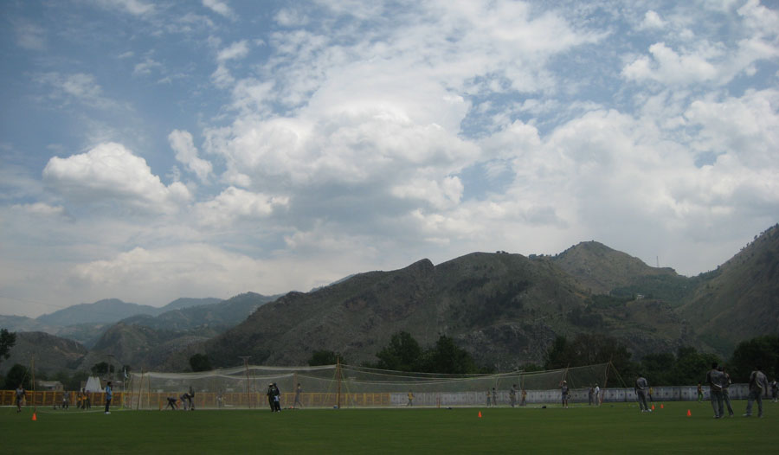
Victoria has a long and rich Cricket history and has been a favoured destination for many touring sides with teams from all over the world visiting to participate in a game of Cricket. Cricket has beenplayed in Victoria since 1863 with teams from Cowichan, Metchosin, OakBay, and Victoria have competed for the championship title to represent Victoriainthe BC championship game.Cricket is also played at the school level especially at St. Michaels University School (SMU) and the University ofVictoria (UVIC) and is continuously attracting young players.
Currently, more than 500 adults participate during the regular season which runs from April to September.These games can attract 100 – 500 spectators. During the season other competitions are held, in particulartheVictoria International Six‑a‑Side (VISAS) Cricket Festival which has been held every second year since 1986. VISAS includes teams from all over the world and draws 200 – 300 spectators every day at theBeacon Hill Park ground.
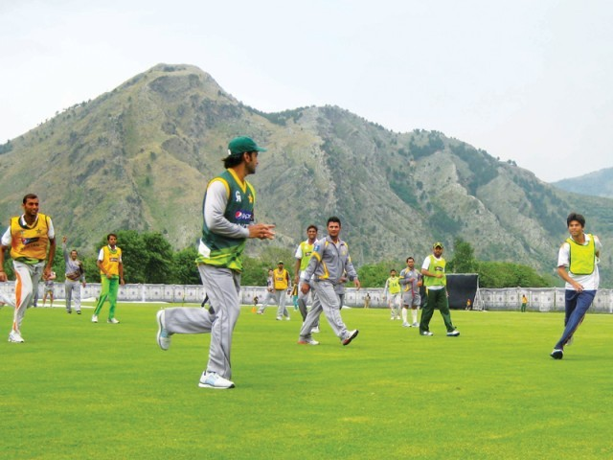

About United Victoria Cricket Abbottabad

United Victoria Cricket Academy Abbottabad Pakistan chapter will soon be launched .The Acadmey site is Abbottabad Cricket Stadium. Number of Cricket Camps are held in Abbottabad Cricket Stadium, it is considered as the summer camp of Pakistan Cricket because of the weather here in summers. Abbottabad Cricket Stadium is also the Home Ground of Abbottabad Falcons.Internaitional players like Younus khan ,Junaid khan and Yasir Hameed represent Abbottabad Falcons.
- Camps & Academies Activities at ACS:
- National Team Camp & Practice Twenty-20 Matches from 09-23 June 2007.
- National Team Camp from 21-28th June 2008.
- Pakistan Women Team Camp from 1st July 2007 to 08th August 2007.
- Pakistan Blind Team Camps & Tournament Matches.
- Pakistan U-19 Team Camp from 9-23rd June 2007.
- NCA Future Players Programs from 15-22 July 2007.
- Abbottabad Regional First Class Team Camps
- Abbottabad Regional U-19 Team Camps
- PCB Regional Academy Training/Coaching Programs
- PCB U-16 Regional Team Camps.
- PCB Elementry Umpiring Course
- PCB Level I Coaching Courses
- PCB Trainer Level I Course
Company Overview
Creating Cricket Stars of Tomorrow! Cricket
Description
Mission:
To provide the highest standard of coaching and programs for all ages
To provide a safe and healthy environment, conducive to development
To provide the best playing opportunities for our players
To provide assistance and guidance for players to help them achieve their goals
Creating Cricket Stars of Tomorrow! Cricket.
General Information
If you wish to successfully coach or play the game of cricket you must have an intimate knowledge of the fundamental techniques of each element of the game.

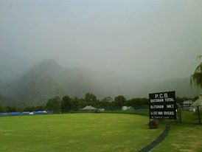 Our Facilities

The United Cricket Academy is situated in the ………….. Facilities include:
• A grass wicket training facility
• A fully three lane wet weather training facility
• Bola Merlyn Spin Bowling Machine
• Bola Pace/Swing Bowling Machine
• Bola Fielding Rig
• Bola Youth Throw down Machine
• All Modern Coaching Aids and Equipment
• Full Run up's for Bowlers
• Sliding Dividing nets and Sightscreens
• Video Analysis unit and Classroom

Sponsorship of UVCA Abbottabad

Sponsorship of UVCC has the following advantages:

- Involvement in our local community, help local community youth to become involved in a sport related activity as part of funds will be used to involve and train youth in coaching clinics and to purchase coaching materials
- Assistance and contribution of funds to the UVIC cricket team
- Exposure of your company’s products and services to the community
- Promotion on both the UVCC and VDCA websites which have over 1,000 visitors per week
- Listing your business in the annual VDVCA hand book which is distributed free of charge to the cricketing community; in 2010 over 800 hand books distributed and this number increases year over year
- Coverage in the local media and in local newspaper as a team sponsor
- Promotional products, handouts, and leaflets
- Ability to attend our annual AGM as a VIP guest
- Your company logo on the UVCC uniform, cap, bats, gear bags, and training uniform

Following are the sponsorship packages with package details to choose and help promote sports activity in Victoria, BC.

*** There will only be one Platinum package sponsor and will be known as official sponsor of UVCC and will be given a prominent area to display logo on uniform and other equipment.

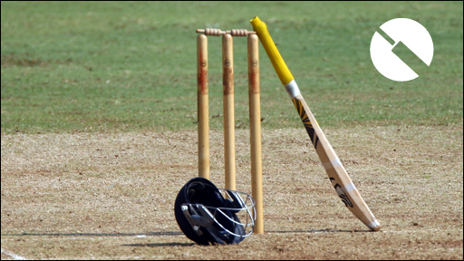

Package Includes | Platinum | Gold | Silver
Company’s Logo on Club Uniform
Company’s Logo on Training Uniform

Company’s Logo on Equipment
Distribution of Company’s catalogues and flyers
Distribution of Company’s catalogues and flyers
Website recognition
Color advertisement in UVCA handbook
B&W advertisement in UVCA handbook
Volunteer players’ participation in company’s community events
Promote company in coaching clinics
Special VIP invitation to Presentation night
Cost | Rs 5,00000 per year | Rs2,50000 per year | Rs1,50000 per year

United Victoria Cricket Club SPONSOR AGREEMENT

Name:
First: __________________ Last: ______________________

Title: __________________

Company: ______________________________________________

Address: _______________________________________________

_______________________________________________________

Phone: ( ) _____ - _________

Email: ___________________________________

This agreement becomes a binding document upon payment in full and signature of both sponsor and the UCVV representative. This agreement guarantees fulfillment of the items listed on the sponsor program benefits (Sponsor Package) and cost sheet. The sponsor will provide items such as: Website link information, company banner, brochures, contact information, etc to optimise exposure benefits and to fulfill the UVCC obligations of the package chosen.

SPONSORSHIP PACKAGE CHOSEN:

Platinum | ------- |  |  | Gold | -------
Silver | -------

____________________ ___________________
Signature of Sponsor Date

________________________________________________ ___________________
Signature of UVCC Date
Representative

